10a. Allocation/Budget Approval Process
Updated 9/30/2017

PURPOSE
U.S. Soybean Export Council (USSEC) must follow the budget process from its funding sources. This is a key component for USSEC’s financial sustainability.

GENERAL INFORMATION
An annual Unified Export Strategy (UES) application is written outlining USSEC’s mission. Project descriptions and proposed budgets are included in the application. USSEC’s funding sources determine the allocations and project budgets through their approval process. The approved budgets must be monitored throughout the year to compare it to actual expenses. It may be necessary to amend the budget and/or the scope of the work during the year.

USB
Allocations
Initial allocation to target areas shall be determined and ratified by the USB Board at the annual Board meeting. Allocation recommendations by Target Area to goal are made by the respective Target Areas and must be ratified by the USB Board. These Target Area specific goal allocations as approved by the USB Board at the beginning of the fiscal year establish the pro rata distribution of all subsequent, non-project specific sources of Target Area funding. All amounts allocated are Board designated net assets.

- Amounts released to action teams and support committees via project budget reductions (turnbacks) in the year of project funding return to the action team from which the project was originally funded.
- Amounts released to action teams and support committees via project budget reductions (turnbacks) subsequent to the year of project funding return to the Board and remain in Board unallocated for reallocation by the Board.
- Unexpended project budget final report of expenditures (FROEs) return to the funding action team in the manner described above “Allocations”.
- Action Team reallocation requests between goals shall be submitted to SMC and Target Areas for evaluation. SMC in collaboration with target area coordinators will submit recommendations to the Board for consideration.
- Carryovers from fiscal year to fiscal year return to the Board to be released to Board unallocated for review by the Strategic Management Committee and Treasurer. Recommendations to the Board for allocations will be based on the Long Range Strategic Plan.
- For the direct-managed programs through the Executive Committee and USDA Oversight programs, FROEs and turnbacks are to be released to unrestricted net assets. There are no unallocated balances and therefore no carryovers for either of these programs. “When in the opinion of the Chairman an emergency exists, the Executive Committee is authorized to approve the expenditure of funds within individual program levels approved by the Board. Approval requires at least two-thirds of its members present at any meeting in which there exists a quorum. Such funding authority shall exist only until the next scheduled Board meeting.”

USB prohibits concurrent implementation of projects with similar, or like, titles, contractors, goals and objectives. Action teams/support committees must determine uniqueness of each project prior to project budget approval.

USB Budgeting
The USB Board is responsible for the budgeting and allocation processes for the National Checkoff funds. Collections are the basis for the development of the USB budget. All budgets, Board-approved projects and amended projects must be submitted to USDA-AMS for approval. Board-approved projects and amended projects that include international activity and/or travel must be submitted to USDA-FAS for approval. All submissions to USDA are made by the USB Program Director on behalf of the Board.

Projects and detailed project budgets must be approved by a majority of the action team/support committee members present at the meeting. Project budgets may not be exceeded and must be managed by the appropriate project manager to approved budget category/ies. If there is no scope adjustment and the total budget is unchanged, budget category adjustments below 10% require internal approvals, between 10% (ten percent) and 19% (nineteen percent) require action team chair/support committee chair approval, and budget category adjustments of 20% (twenty percent) or greater require action team/support committee approval.

For example for a total project budget of one million dollars with a $50,000 subcontractor budget category;
- with an increase or decrease to the subcontractor budget category less than $5,000 would not require approval
- with an increase or decrease to the subcontractor budget category between $5,000 and $9,999 would require approval by the action team chair/support committee chair
- with an increase or decrease to the subcontractor budget category of $10,000 and greater would require approval by the action team/support committee

Project total budget adjustments (increases or turnbacks) and/or scope adjustments require action team/support committee approval.

USSEC - Internal Process for Budget Modifications, Scope Changes, and Date Amendments
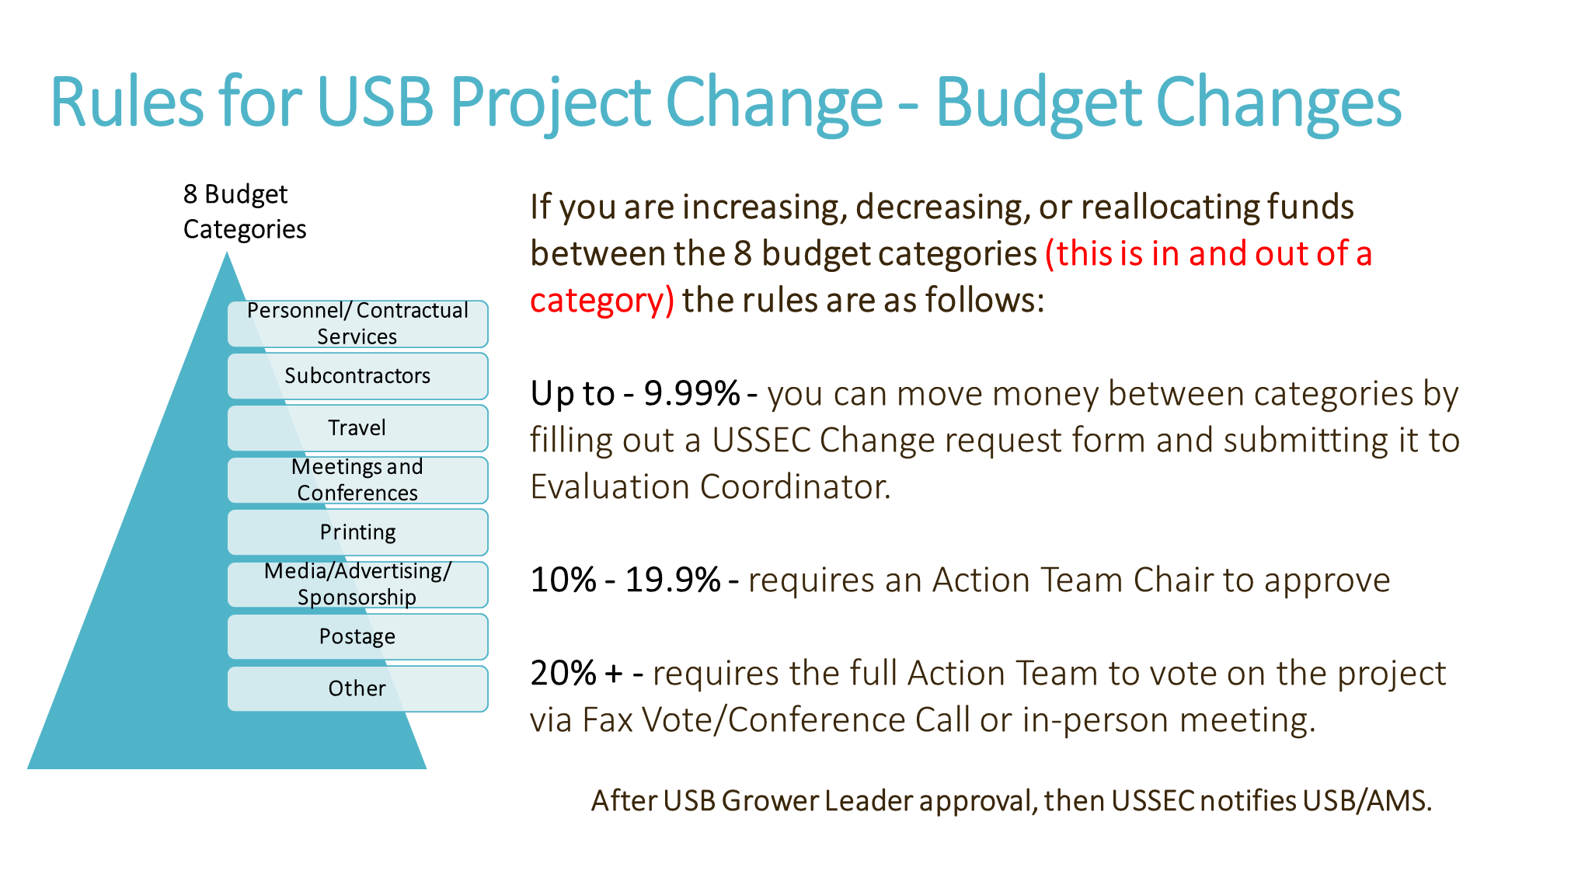

Steps
- Submitter sends request to Action Team Lead and Project Manager
- Include a redline version of the project description including budget change requests. Be sure to start with the current version of the project description
- Include strong justification for change request including things such as…
  - more or less attendees
  - the market
  - currency exchange
  - airfare costs
- Project Manager sends the request to the Project Implementation & Quality Control Manager for final USSEC review.
- USSEC’s Project Implementation & Quality Control Manager writes a formal approval request on behalf of USB and sends the request to USB.
- USB reviews and sends the approval request to USDA – these submissions to USDA are made by the USB Program Director on behalf of the USB Board.
  - Agricultural Marketing Service (AMS) – All projects
  - Foreign Market Development (FAS) – Projects that include international activity and/or international travel.
- Once USDA approvals (AMS and FAS) are received, all records are updated at USSEC.

FAS
Allocations
The Foreign Market Development Program (FMD) allocation is based upon competition from other FMD Cooperators, USSEC’s leveraged dollars from other sources, past export performance, past demand expansion performance, future demand expansion goals, and the accuracy of past demand expansion projections.

The Market Development Program (MAP) allocation is based competition from other MAP participants, the project value of exports, actual value of exports in prior years, past projections of exports compared with actual exports, USSEC’s leveraged dollars from other sources, market share goals in target countries, and proposed MAP-funded general administrative and overhead costs compared to proposed MAP-funded direct promotional costs.

FAS Budgeting
The Foreign Agricultural Service (FAS) is responsible for announcing the distribution of program funds to the FMD Cooperators and the MAP Participants. The allocations are typically not known until after the FMD program year has started. Once the allocations are known, USSEC leadership will compare the allocation to the total requests. If there is a shortfall, the most critical projects will be funded.

USSEC - Internal Process for Budget Modifications, and Scope Changes
Steps
- Submitter sends Project Manager and Project Director request for approval
- COO must approve all budget transfers between projects, all new projects, and all scope changes. A budget modification within the same project does not require COO approval unless there is a scope change.
- With the approval request, include a redline version of the project description showing any budget changes. Be sure to start with the current version of the project description
- Include strong justification for change request including things such as…
  - more or less attendees
  - the market
  - currency exchange
  - airfare costs
- Project Manager sends the approved approval request to the Budget and Compliance Administrator for processing.
- Changes to FAS projects can either require an approval or just a notification to the ASA/TPIA Committee and FAS.
  - Approvals
    - Administrative changes
    - Changes in staffing in overseas offices
    - Office openings and closings
    - Computer & IT purchases; furniture & equipment purchases
    - New markets
    - New regions or changes to regions
    - New or changed constraints
    - Changes in performance indicators or goals
    - New or changed evaluations
    - New projects
    - Expenditures in the United States that not already approved within the project.
    - Sales and Trade Related Expenses (STRE) that exceed post limits
    - New or modified policy-related projects
    - New constraints
    - Project scope change
    - Significant budget changes – more than $25,000 or 25% of project budget whichever is greater.
  - Notification Only
    - Budget changes that are less than 25% or less than $25,000.
    - Change in location of event as long as the scope of the project has not changed.
TPIA Approval Process
- Before a revision that requires approval is submitted to FAS, the approval of the American Soybean Association/Trade Policy and International Affairs (ASA/TPIA) Committee is required.
  - Electronic Vote (E-vote) thru DocuSign
- Purpose: To receive a majority vote from the ASA/TPIA Committee to present the revised project to the Foreign Agricultural Service (FAS).

- Timing: Must allow at minimum of five (5) calendar days between the time ballot is sent to the deadline.

- Sender: All E-votes are to be coordinated by the Budget & Compliance Administrator or approved designee in order to properly record, count, and report the results.
  - Receivers of E-Vote: ASA/TPIA Committee Members, USSEC Chair Person, USSEC CEO, USSEC COO, USSEC CFO, ASA CEO, FAS Branch Field Crops & Forest Products Branch Chief, FAS Marketing Specialist. Only the ASA/TPIA Committee Members will be voting.
    - E-Vote Results: All votes are tallied and the results are emailed to those involved in the E-vote. Management notes are prepared summarizing the outcome and then distributed.
FAS Approval Process
- The Budget & Compliance Administrator sends FAS a request for approval via the UES Online Application as well as a follow-up email.
- Must allow at least 3-days for FAS to review.

Once the TPIA Committee and FAS approves the change, all records are changed at USSEC accordingly.

