# 8a. ACCOUNTING PROCEDURES

Updated 9/30/2018

**OVERVIEW**

The CEO will oversee and ensure the CFO is responsible for:

* Establishing internal controls.
* Establishing a standardized chart of accounts that provides for accurate and consistent recording and reporting of accounting transactions in accordance with Generally Accepted Accounting Principles
* Ensuring adequacy of chart of accounts recording and reporting of accounting transactions in order to comply with all Board required reporting guidelines, such as reporting by budget and fiscal year.
* Ensuring all month end close activities are completed in a timely manner.

A uniform and consistent process will be followed for adding, deleting and modifying the chart of accounts and the financial reporting structure.

Accounting will implement month-end procedures including all necessary reconciliations, accruals and journal entries. These will reflect the appropriate authorizations and audit trail.

The Accounting department performs the necessary procedures to review, approve, and record all accounting transactions in accordance with USSEC compliance regulations and Generally Accepted Accounting Principles.

**GENERAL LEDGER**

The General Ledger (GL) is the collection of asset, liability, net asset, revenue, and expense accounts. It is used to accumulate all financial transactions which provide the details needed for financial reporting purposes.

**CHART OF ACCOUNTS**

The Chart of Accounts (COA) is the framework within the GL. It consists of account titles and account numbers (4 digits) used to organize transactions by type. USSEC’s chart of accounts is comprised of five types of accounts numbered as below.

Assets 1000-1999

Liabilities 2000-2899

Net assets 2900-2999

Revenues 3000-3999

Expenses 4000-9999

**ACCOUNT STRUCTURE**

Sub-accounts are used with each account number to further segregate data. Sub-accounts are 10 alpha/numeric characters that allow the grouping of transactions according to funding source, region, country, target area, and expense class.

**FINANCIAL CONTROLS**

Separation of duties is an essential internal control process in which financial tasks and privileges are separated between multiple users so as to prevent fraud and minimize error. USSEC’s separation of duties is outlined in the Delegation of Authority matrix.

**Banking**

* + - Whenever possible, separate bank accounts will be maintained for the funding sources listed below. In the event the account is shared, funds are segregated by subaccount in order to ensure the funds are segregated.
    - USB
    - FMD
    - MAP
    - FAS Other (QSP, EMP)
    - Membership
      * Board-Designated
      * Undesignated
      * Contingent Liabilities
      * Reserve
  + Positions authorized on bank signatory cards per the DOA MATRIX
  + All payments will be authorized per the DOA MATRIX
  + U.S. deposits will occur as needed and will be approved according to the DOA MATRIX
  + A line of credit is maintained for the sole purpose of Checkoff-eligible expenditures. The renewal of this line is annual, and subject to approval and guarantee per the DOA MATRIX
  + Interest on the line of credit is recorded monthly and billed to USB – maximum chargeable amount is denoted in the USB/USSEC Management Agreement for the respective fiscal year

**Definition of Admin, Project Support and Project Expense Account Structures**

**General Administrative Expense (Classified as Administrative Expenses or ‘A’ subaccount ending)**

General administrative expenses include salaries and related benefits of those employees who perform administrative/clerical (non-technical) activities, and other non-salary administrative expenses incurred to support "ALL" projects.

General administrative expenses are necessary costs that are associated with the management, clerical, and general functions within an organization that cannot be directly applied to some expense category related to a specific project. These are costs that offer a wide benefit to the organization. As such, their benefits transcend project lines and make it possible for the many necessary functions to successfully take place. Sometimes considered part of general business expense, among many other expenses these administrative expenses can take the form of such basic needs as rental space for the business, the cost of utilities, or even the salaries of personnel that are not involved in the marketing efforts of a project. For expenditures classified as a general administrative expense where a material amount of time and resources were associated to projects, consideration should be given to classify the expense as an Indirect Project Expense. A reasonable standardized allocation will need to be identified.

**Indirect Project Expense (Classified as Project Support or ‘S’ subaccount ending)**

Indirect project expenses are costs that can be identified as beneficial to multiple projects or a specific region, but not a particular project. For the most part, any expense that can be identified as directly benefiting multiple projects or region of the organization, while offering little or no direct benefit to a specific project, can be considered an indirect project expense.

Indirect project expenses are project support expenses by nature but have a direct relationship to multiple projects or a region. Examples of such expenses are as follows:

• Contract preparation or review for project for Americas.

**Direct Project Expense (Classified as Project or ‘P’ subaccount ending)**

Direct project expenses are costs that can be identified specifically with a particular project, or that can be directly assigned to such activity relatively easily with a high degree of accuracy.

**Determining the Proper Classification**

Answer the following questions in order to determine the proper classification of the given expense.

1. Does expense/activity facilitate the marketing of United States soy?

a. If no, classify to General Administrative Expense (subaccount should end with A)

b. If yes, continue to Question #2.

2. Does expense/activity benefit only projects?

a. If no, classify to General Administrative Expense (subaccount should end with A)

b. If yes, continue to Question #3

3. Does expense/activity benefit multiple projects?

a. If yes, classify to Indirect Project Expense (subaccount should end with S)

b. If no, continue to Question #4

4. Does expense/activity directly benefit an individual project?

a. If yes, classify to Direct Project Expense (subaccount should end with P)

b. If no, review the answers to the above questions to verify all answers were

appropriate.

**ACCOUNTING PROCEDURES REGARDING ASSETS**

**CASH**

Cash is the most liquid asset of an organization, and therefore cash procedures follow the strongest possible internal controls. The responsibilities of billing, receiving, holding, recording, and reconciling funds are each given to different accounting positions in order to reduce the risk of loss.

**Electronic Bank Transactions**

* Receipt of funds are reconciled on a monthly basis.

**Checks received**

* + Mail is opened by the administrative assistant, who enters any checks received into a check log, then gives the checks to accountant #1.
  + Accountant #1 makes a copy of the check, determines which general ledger account the money will be posted to, and enter this information in the check log.
  + Checks are locked in the Controller’s office until ready to be deposited.
  + At the time of deposit, Accountant #2 creates deposit slips and prints the check log, giving both to the Controller.
  + The Controller reviews the checks, copies, deposit slips, and check log, and approves the log with a signature.
  + Accountant #2 deposits the checks, returning the deposit receipts to Accountant #1.
  + Accountant #1 reconciles the bank receipts back to the check log for accuracy, and posts the checks to the general ledger.

**PETTY CASH**

* + As dictated by normal established business practices unique to each country, the Country/Regional Director shall establish a maximum amount of petty cash maintained in the office not to exceed the equivalent of US $300.00
  + As dictated by normal established business practices unique to each country, the Country/Regional Director shall establish a maximum amount per petty cash claim not to exceed the equivalent of US $50.00
  + Control
    - Petty cash shall be maintained under a secure environment
    - Country/Regional Director and one additional designee may have access to petty cash fund
  + Reconciliation
    - Each month the petty cash fund is to be reconciled
    - The Country/Regional Director must review and approve each monthly reconciliation

**PREPAID EXPENSE ALLOCATION**

Expenses are charged to the Prepaid Expense Account (GL #1201) if the amount that benefits *future fiscal quarters* is US $100.00 or greater. If the amount that benefits a *future fiscal year* is less than US $100, it may be expensed in the current fiscal year, in the appropriate fiscal quarter.

Home Office will transfer amounts from 1201 to expenses in the appropriate quarter. This is when expenses will show on the projects. For example, expenses such as subscriptions, memberships, and insurance premiums, usually have terms of one year and require pre-payment. The current portion is expensed and the future portion is posted to a prepaid expense account on the balance sheet (only if that amount is greater than $100, per USB policy.) Accounting later, in the appropriate period, moves the prepaid amount to expense.

When these types of expenses are paid, a cost allocation worksheet and prepaid form must be sent to accounting with the voucher for approval. These forms calculate the amount of expenses to be allocated to each appropriate fiscal period.

**FIXED ASSETS**

A Fixed Asset is a piece of equipment, furniture, or fixture with a purchase price of $500.00 for FAS and $2,500.00 for USB or more per item and an expected useful life of more than one (1) year.

The expected useful life of assets are as follows:

|  |  |
| --- | --- |
| **Asset Class** | **Common Class Life** |
| Office furniture, fixtures and equipment | 7 years |
| Information systems/ Computers | 3 years |
| Data handling equipment | 3 years |
| Leasehold improvements | Lesser of remaining lease term or 15 years |

* Asset purchase
  + Each Asset purchase of $1,500.00 or greater requires the following prior to purchase:
    - A completed Asset Request Form, with appropriate approval per the DOA MATRIX.
    - Three Competitive Bids when an item costs more than $2,000.00
* Asset disposal
  + Each Asset disposal requires the following prior to disposal:
    - Appropriate Funding Source approval in writing
      * FAS requires approval from the local Post or Attaché office
      * USB requires approval from the USBExecutive Director only if the item to dispose is a cell phone less than 2 years old or a technology item less than 3 years old
    - A completed Asset Disposal Form, with appropriate approval per the DOA MATRIX
    - Laptops or desktops that are disposed must be sent to the Home Office for disposal by the IT Manager.
* Asset tracking
  + All offices are to conduct a semi-annual physical inventory of Assets (March and September). Inventory lists should be submitted to Home Office accounting. Any variances should be brought to the attention of the respective Director and Home OfficeAccounting
  + Home Office Accounting maintains an asset tracking list, which includes:
    - Asset number assigned by USSEC or USB
    - Date of purchase or acquisition
    - Cost of purchase
    - Serial number
    - Make
    - Model
    - Electrical requirements

**MEMBERSHIP FUNDS**

Types of membership funds

* + - Board-Designated Membership Funds are dues collected from Checkoff entities and are internally designated. They are NOT to be used for:
    - Solicitation of Undesignated Membership Funds
    - Influencing government policy
    - Or for any purpose not in conformance with the Soybean Promotion, Research, and Consumer Information Act (7 U.S.C. 6301-6311) and the Soybean Promotion, Research, and Consumer Information Order (7 CFR Part 1220)
    - Undesignated Membership Funds are dues collected from all other types of membership

Segregation of funds

* + - Board-Designated Membership Fundsand Undesignated Membership Funds are held in separate accounts (whenever possible as required by law).

Use of funds

* + - Board-Designated Membership Funds pay approved eligible operational expenses with an emphasis on providing benefits to support industry participation including USSEC meeting expenses and other activities or projects that promote export of U.S.-origin soybeans and products
    - Expenditures are approved per the DOA MATRIX
    - Undesignated Membership Funds Pay organizational expenses related to:
    - Solicitation of Undesignated Membership Funds
    - Influencing government policy
    - Or for any purpose not in conformance with the Soybean Promotion, Research, and Consumer Information Act (7 U.S.C. 6301-6311) and the Soybean Promotion, Research, and Consumer Information Order (7 CFR Part 1220)
    - All other Undesignated Membership Funds will be held until an expenditure is approved by proper procedure or swept to Reserve
    - Approvals
    - All expenditures will be approved per the DOA MATRIX
    - Once all expenses have been recorded for the calendar year, 25% of any carryover Undesignated Membership Funds will be swept to the Reserve account and considered net assets (effective 2008 and beyond)
    - Additional allocations can be made to Reserve at the discretion of the USSEC Board
    - USSEC Reserve should be maintained at a level of no less than $100,000, once that threshold is reached. Should the Reserve fall below this amount, Board action may be requested.

**PROCEDURES REGARDING LIABILITIES**

**Accounts Payable**

* + Assets or expenses and the related liability are recorded by an individual who is not responsible for ordering or receiving.
  + Invoices must be supported with the required documentation and properly authorized according to the DOA matrix.
  + Accounts payable transactions are processed on a daily basis, and information is entered into the system from approved invoices or disbursement vouchers with appropriate documentation attached.
  + Only original invoices will be processed for payment unless duplicated copies have been verified as unpaid by researching the vendor records. No vendor statements shall be processed for payment.
  + Vendor credit terms and operating cash are managed for maximum benefits.

**Accrued Liabilities**

* + For purposes of preparing quarterly financial statements, liabilities will be accrued in the appropriate fiscal quarter. Some of the expenses typically accrued are:
    - Vendor invoices received, approved, and supported with proper documentation
    - Salaries and payroll taxes
    - Vacation pay

**CORPORATE CREDIT CARD PROGRAM**

* + The CFO administers and controls the corporate card program
  + Applications should be requested from the CFO for eligible employees
  + Use of the card
    - The corporate cards are intended for business use only.
    - Cards can be used for car rental, lodging, airfare, meals, and all other business expenses
    - No late charges will be reimbursed
    - For USSEC staff, non-reimbursement of expenses incurred does not relieve employee of the obligation to pay charges incurred on their card
    - For Group Event (centrally-billed) accounts, appropriate uses are:
      * Consultant, staff, and grower leader airfare
      * Team hotel and transportation
      * Seminar registration fees and venue costs
  + Submitting expenses to Accounting
    - Accounting will send each cardholder a copy of the transactions charged to their card each month.
    - Cardholders are required to:
      * Validate each entry on the statement
      * Determine appropriate project and activity for each entry
      * Submit proper substantiated documentation and completed Corporate Card Reconciliation Worksheet to Accounting within 30 days from receipt of transactions providing by the Accounting Department.

**PROCEDURES REGARDING FINANCIAL REPORTING**

**INTERNAL REPORTING**

* Daily
  + Financial transactions prepared by accounting staff are reviewed and approved by the Assistant Controller, Controller or CFO
* Monthly
  + All bank accounts are reconciled by accountants and reviewed by Assistant Controller
  + All balance sheet accounts are reconciled by accountants and reviewed by Assistant Controller or Controller
* Quarterly
  + All bank accounts are reviewed by Controller
  + All balance sheet accounts are reviewed by Controller
  + Financial statements are prepared and analyzed by Controller, then reviewed and approved by CFO
* Annually
  + Outside audit firm conducts an audit and prepares audited financial statements

**EXTERNAL REPORTING**

* Monthly
  + Documents are provided to primary funding sources as outlined in agreements.
* Quarterly
  + Internally-prepared financial statements are provided to the A&B Committee, banking representative and other designated stakeholders as follows.
  + Documents are provided to primary funding sources as outlined in agreements.
* Annually
  + Externally audited financial statements are provided to the USSEC Board for review and acceptance.
  + Externally audited financial statements are provided to the banking representative, USB CEO and ASA CEO following USSEC Board approval
  + Annual budget is provided to banking representative within 30 days of start of fiscal year
  + Documents are provided to primary funding sources as outlined in agreements.
* Exceptions
  + Any exceptions to the above will be approved per the DOA MATRIX

**RECORD RETENTION**

All USSEC record retention requirements are in accordance with USB policy. Refer to USB policy for definitions.

* Records Screening
  + - Records are to be screened periodically to determine if they are Active or Inactive. Active records are to be stored in the immediate area of the responsible custodian.
    - Records determined to be Inactive are to be reviewed for possible storage in the designated Records Center. An assessment is to be made of the:
      * Need for retention
      * Frequency of reference
      * Name of reference
      * Established retention period
      * Filing requirements
      * Volume of files
    - Duplicate and multiple materials, as well as paper and binder clips, are to be eliminated. Whenever possible, Official Record is the one to be retained. Official Records are not to contain personal notations, other than the author’s signature.
* Records Center Storage
  + - Records Storage Centers are to be in a safe, secure location and protected from environmental and other potential harm.
    - Storage containers are to be labeled using the numbering system in the USSEC Inventory List spreadsheet. This is a log of box numbers, locations, and contents. Containers are also to be labeled by year or periods and with sufficient detail to facilitate their reference, review and destruction.
    - Records which are essential to the continuity of USSEC are to be identified and designated as Vital Records.
    - Vital Records are to be duplicated and the duplicate records stored in off-site locations for reconstructive use in the event of a disaster.
* Electronic Storage
  + - Records generated and maintained in company information systems or equipment (including the network drive) are to be periodically reviewed by the individual records custodians to ensure that the records management requirements set forth in the USSEC’s policy and procedures handbook are being met for electronic information systems.
    - Records stored in electronic media are to be grouped in a fashion to facilitate review and destruction at appropriate intervals.
* Files Purging
  + - At least once annually, a formal files-purging process will be conducted. The process is to be planned and carried out within applicable areas of responsibility. During, or as a result of, this process:
      * Records that require retention are to be identified, grouped, labeled, and transferred to the records center for appropriate storage;
      * Records that have exceeded their required retention period are to be reviewed and destroyed, and
      * Unnecessary duplication and multiple copies of records are to be identified and destroyed.
* Responsibilities
  + - Each staff/contractor personnel is responsible for assisting in the records-management process. Such responsibilities generally include:
      * Supporting preparation and maintenance of local records retention schedules;
      * Identifying, packaging, documenting and transferring applicable records to the records center;
      * Retaining only those records assigned to their function/custodial responsibility in accordance with the guidelines of our record retention policy;
      * Retrieving records from the records center within the time period established by the records management function; and
      * Reviewing and authorizing destruction of records at the retention expiration date.

|  |  |
| --- | --- |
| **RECORDS RETENTION** | |
| 1. **ADMINISTRATIVE** 2. Manuals |  |
| 1. Policy Manuals and other directives that express or interpret USB policy    * Originating office file copy    * Other copies    * Drafts and work papers | Until 10 years after superseded  Until superseded  Until completion of manual or until no longer useful |
| 1. Procedural Manuals and other directives that are procedural only and do not express new policy or interpretation (includes Records Management Guide)    * Originating office file copy    * Other copies | Until 5 years after superseded  Until superseded |
|  |  |
| 1. Reports |  |
| 1. Administrative – Internal    * Originating office file copy    * Other copies    * Drafts and work papers | Year originated + 7  Until superseded  Until completion of report or until no longer useful |
| 1. Annual (year-end or last quarter)    * Originating office file copy and work papers    * Other copies | Year originated + 7  2 months |
| 1. Quarterly    * Originating office file copy and work papers    * Other copies | Year originated + 7  2 months |
| 1. Correspondence 2. Letters    * Supporting a principal document or project    * Routine that require no acknowledgement or follow up    * Chronological correspondence files    * USDA Chairperson (letters supporting a document or project) 3. Internal memos and notes 4. Handwritten notes 5. Electronic Email Correspondence | Retained for the life of the principal document or project  Year originated + 1  Year originated + 1  Permanent  Year originated + 1  Year originated + 1  24 months |
|  |  |
| 1. **CONTRACTS AND AGREEMENTS** |  |
| 1. All contracts and final reports (with the exception of QSSB related contracts – see below for requirement) | 5 years from contract expiration |
| 1. Building leases, permits and operating agreements 2. Signed original 3. Other copies | Until 10 years after the termination of the lease/permit/agreement  Until termination of the lease/permit/agreement |
| 1. **CORPORATE RECORDS** |
| 1. Certificates of Incorporation, Bylaws | Permanent |
| 1. Minutes of Board Meetings and Committees 2. Record copy 3. Copies and excerpts | Permanent  Year originated + 1 |
| 1. Long-range Strategic Plans 2. Strategies, Action Plans 3. QSSB Consulting or Oversight    1. Agreements and Contracts    2. Compliance Review Reports    3. Other Compliance (excluding QSSB financial needs) 4. **PROJECT FILES** 5. Official file 6. Supporting documentation/notes/work papers | Until 5 years after superseded  Until 5 years after superseded  Permanent  Permanent  Permanent  5 years from completion of the project  Until completion of the project + 1 year |
| 1. **FINANCIAL** |
| 1. Accounts Payable and other payments 2. Daily activity reports, invoice lists 3. Daily control statements, batch control reports, daily distribution summary 4. Monthly distribution reports, corrected general ledger summary reports 5. Invoices, accumulated data for payment of invoices and necessary related documents 6. Payment reports    * Semiannual payment reports    * Daily, bimonthly and monthly reports | Year originated + 7 and after audit  Year originated + 1  Year originated + 6 and after audit  Year originated + 7 and after audit  Year originated and after audit  While useful |
| 1. Accounts Receivable and other receipts 2. Cash receipt documents, check Photostats 3. Cash receipts ledger 4. Petty Cash records 5. Customer history records – any form 6. Registers – cash, control report, invoice, journal, split cash, washout 7. Trial balances | Year originated + 3 and after audit  Year originated + 6 and after audit  Year originated + 6 and after audit  Year originated + 6 and after audit  Year originated + 6 and after audit  Year originated + 6 and after audit |
| 1. Audit 2. External audit reports 3. Internal audit reports | Permanent |
| 1. Banking 2. Bank account statements and reconciliations 3. Bank Resolutions-Board Minutes 4. Depository receipts | Year originated + 6 and after audit  Until resolution is revoked  Year originated + 3 |
| 1. Billing | Year originated + 1 |
| 1. Budget |  |
| 1. Actual versus budget financial reviews 2. Actual versus budget reports for expenses    * Monthly    * Year end    * Other copies and excerpts 3. Budget documents 4. Corporate Insurance Agreement | Year originated + 5  Year originated + 1  Year originated + 10  While useful  Year originated + 10  Permanent |
| 1. Company ledger, financial statements and reports of finances: 2. Financial Statement-documents that report the financial circumstances of USB    * Company copy and essential work papers    * Board minutes    * Other copies 3. General ledgers 4. Journal entries | Year originated + 25  Permanent  While useful  Year originated + 25  Year originated + 10 and after audit |
| 1. Expense reports and travel statements of personnel | Year originated + 4 and after audit |
| 1. Individual authorizations for expenditures | Until superseded + 5 years |
| 1. Royalty payments and receipts required by contracts, agreements, etc. | Until 6 years beyond expiration of agreement and after audit |
| 1. **EMPLOYMENT RECORDS** |
| 1. Application and resume 2. If hired 3. If not hired 4. If unsolicited 5. Disciplinary action 6. Employment contracts 7. Goals documents 8. Performance, results reviews or appraisals 9. Training courses 10. Job descriptions and advertisements 11. Salary-increase planning sheets | Duration of employment + 3 years  Year originated + 1  Return to sender or acknowledge it and then destroy it  Year originated + 1  (See Contracts and Agreements)  Year originated + 1  Duration of employment + 3 years  Duration of employment + 3 years  Until 1 year after superseded  Year originated + 1 |
| 1. **COMPLIANCE** 2. Data collected to demonstrate compliance 3. All copies 4. Drafts and work papers | Until purpose served or as required by law  Until completion of report |
| 1. **INSURANCE** |  |
| 1. Annual Insurance Policy 2. Insurance Claim Files 3. Insurance certificates furnished by contractors working on USB premises | Permanent  Permanent  Permanent |
| 1. **TAX** |  |
| 1. Exemption Certificates | Expiration of exemption + 5 years |

VIII. APPENDICES

1. **DOA-Matrix**

On the following pages:

* USSEC DOA (Delegation of Authority Matrix)
* USSEC Chart of Accounts (Expenses Only)
* USSEC Chart of Accounts Category Roll-up (Expenses Only)
* USSEC Subaccount Structure

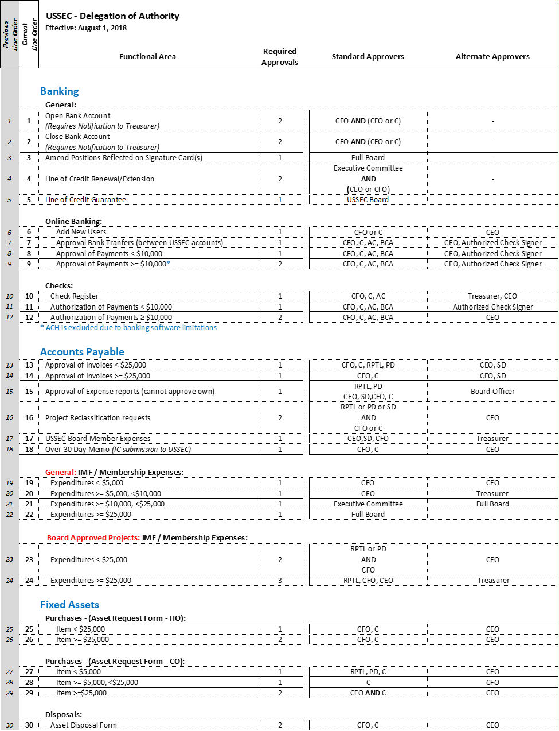

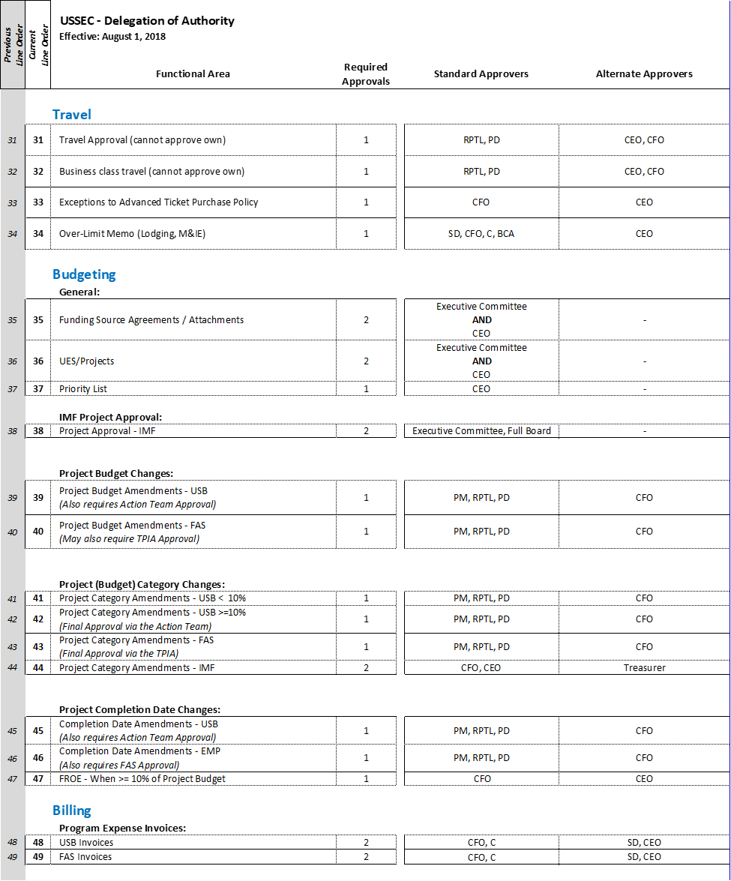

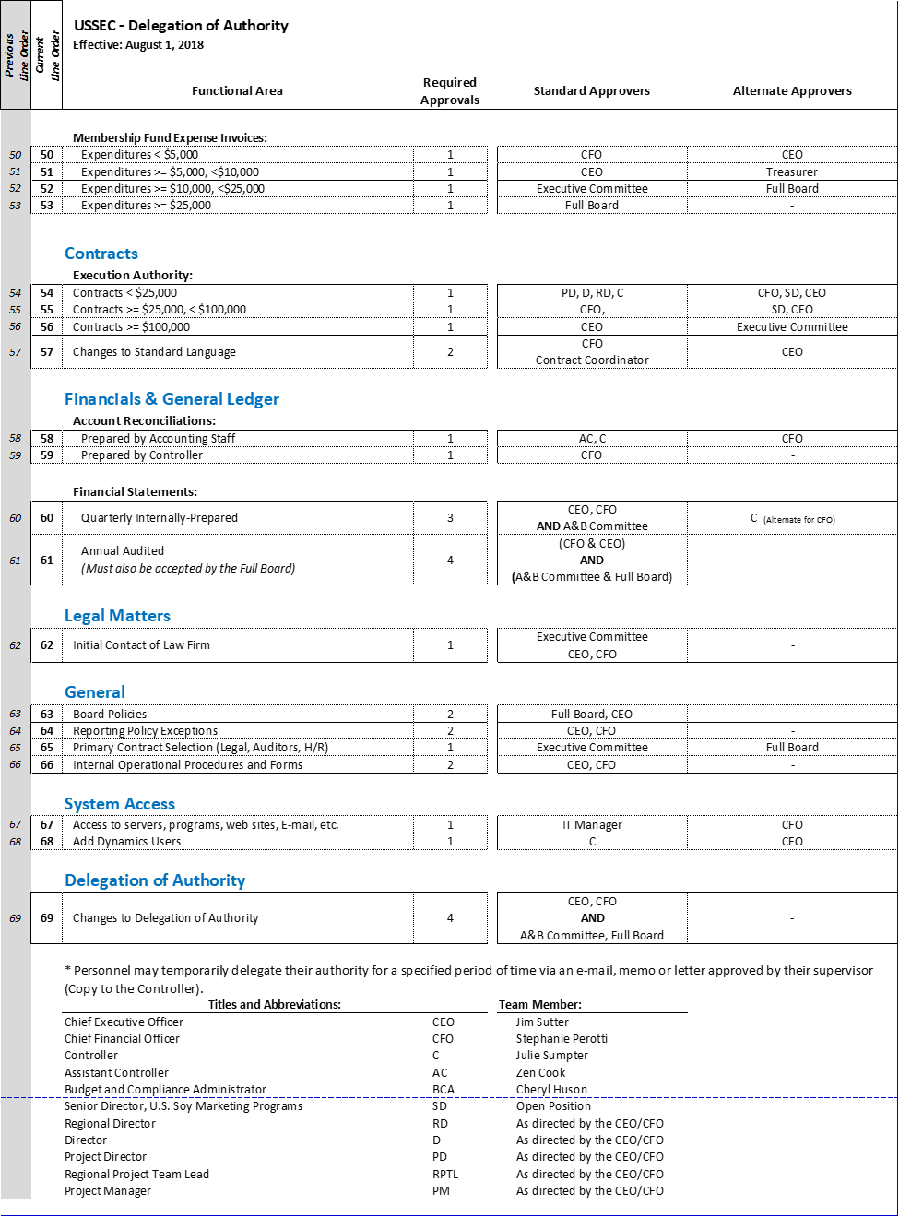

# USSEC Chart of Accounts (Expenses Only)

# 









# USSEC Chart of Accounts – FAS/IMF Category Roll-up (Expenses Only) –

# USSEC Chart of Accounts – FAS/IMF Category Roll-up (Expenses Only)… (Continued)

|  |  |  |  |
| --- | --- | --- | --- |
| **Category** | **GL Acct. Code** |  | **Account Name** |



# USSEC Chart of Accounts – USB Category Roll-up (Expenses Only)



# USSEC Chart of Accounts – USB Category Roll-up (Expenses Only)… (Continued)

# 

# USSEC Chart of Accounts – Corporate Admin Category Roll-up (Expenses Only)



# FORMS AND INSTRUCTIONS

Expense Form

#### 

Asset Request Form

#### 

Asset Disposal Form

#### 

STRE Name List Form

#### 

Grower Leader Marketing Mission Summary Report

#### 

Lodging Over Per Diem Memo

#### 

Contract Request Form



FAS 2019 Contracts



FAS 2018 Contracts



(Interim) Advance Notification for Consultant/ Grower Leader

#### 

(Interim) Advance Notification for Team Visit



Over 30 Day Expense Submission Memo



Domestic / International Flight Exception Memo

